Viewing my Electronic Health Record

An Introduction for Patients

Online Electronic Health Record

Empowering and Educating Patients

Supported By
Greater Huddersfield Clinical Commissioning Group

Patient Information Guide

An Introduction to Viewing My Electronic Health Record Online
Please use the information in this guide to help you decide if you want access to your Electronic Health Record.
What is an Electronic Health Record?
- An Electronic Health Record holds important information about your health including: the dates you were seen by a Doctor or nurse, what was wrong with you, any investigations ordered (for example blood tests, x-rays) any test results, what medicines you were prescribed and copies of letters sent or received from any team dealing with your healthcare.
You can now see your Electronic Health Record via the internet if you have the right equipment (for example a home computer or laptop). To be able to see it, you will need to log on to a website using a password. We also need your permission to create access to the system where your record is kept.
Why you might want to see your Electronic Health Record
- I can have the information I need to make an informed choice
- I can have a say in making decisions about my treatment and care along with a healthcare professional
- I can check the accuracy of my Electronic Health Record and ask the GP practice to amend if necessary
- I feel empowered to become more involved in my healthcare
- I can access it if needed on holiday or abroad
- I can view test results without having to contact my GP practice
- I am confident that my GP practice is open, honest and trustworthy
- I have the convenience of accessing my record seven days a week, 24 hours a day
Is my confidential medical information safe whilst I am looking at it online?

- The details you can see online come from a national clinical IT system that your GP practice uses. This IT system encrypts (scrambles) information to make it very difficult for anyone else to receive or see it.
- Your medical information is not kept on a computer in your surgery. It is held in the secure national IT system and your password access calls the information from that server to your computer so you can see it. This is also how staff at your GP practice view or add information to your record.

What will I see in my Electronic Health Record?
- A summary of your health record showing the most important and recent entries. The date of any consultations you’ve had with a GP, practice nurse or other health practitioner with details about the reason for your visit, who you saw, any examinations and the result of the visit. Details of what the doctor thought was wrong with you and any tests or medical investigations that were needed.
- A note of anything you’re allergic to.
- Patient Information Leaflets linked to your medical conditions
- Test results
- Vaccinations
- Medicine you’ve been prescribed
- Letters to or about you sent by your practice
Registering and consenting to viewing my Electronic Health Record

- Firstly you need to see the receptionist at your GP practice and ask how to register to view your Electronic Health Record.
- You must register with the GP practice and sign a consent form before you can start viewing your Electronic Health Record.
- Before you sign the consent form, you must make sure that you have read and understood the information in this guide.
- Hand your signed consent form to the surgery receptionist.
A member of the practice team will get in touch to confirm your online access to your records – please allow five working days for this to be sorted.

What if I find a mistake when viewing my Electronic Health Record?

- If you think there are mistakes or information is missing from your medical record you can use the online messaging system (if your practice has enabled it) to tell your practice. If the online reporting is not available then please:
- Tell the receptionist
- Discuss it with your GP
- If you see someone else‘s medical information you should log out of the systems straight away and tell your GP practice about it. Please do not share any information that isn’t about you with anyone else.

Is viewing your Electronic Health Record right for you?
If you decide that having access to your Electronic Health Record online is right for you, please fill in the patient questionnaire at the end of this information guide and then sign and date it. Give the form (with the pass phrase you will have chosen) to the receptionist.
If you are completing the form for someone else because they can’t do it themselves, please sign the consent form.

Creating Your Own Passwords
Tips for creating a good (strong and secure) password:

- Include both UPPERCASE and lowercase letters.
- Use letters and numbers but NOT your date of birth.
- Don’t repeat the login name you chose as part of your password.
- Don’t use any example of a good password that you might have seen somewhere.

Create an easy to remember password:

Think of a sentence or saying that means something to you and then pick the first letter of each word in that sentence/saying. Add at least one number in somewhere. A combination of numbers and letters is harder to guess or crack with a computer program.

For example:
"I love to shop for sandals in the Spring." (Il2s4sitS)
12 x 12 are 4412x12r144)
"I'm going to work out 3 times a week." (Ig2wo3taw)
"Last summer I caught a 30 inch striped bass." (LsIca30isb)
My password needs to be 8 letters long (mpntb8ll)

A similar method is to take out all the vowels from a short phrase.
For example:
"I work 8 hours a day." (wrk8hrsdy)

Glossary of Terms

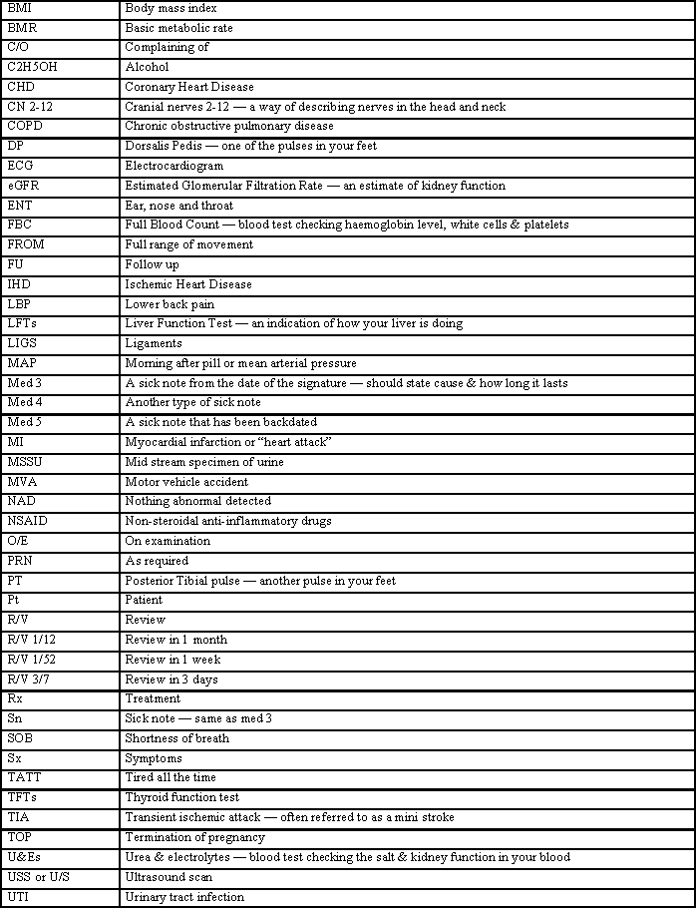

If you come across any abbreviations that you do not understand, please get in touch with your surgery and one of the team will find the answer for you.

Or you could try this website which may be helpful. http://www.pharma-lexicon.com

